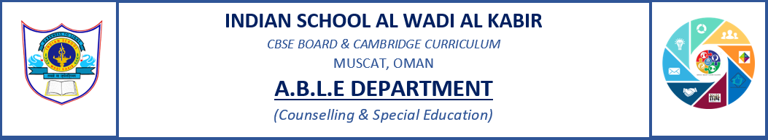
MOTHER’S DAY SPECIAL ASSEMBLY

Motherhood is a selfless responsibility, A mother is a woman who not only gives birth, by experiencing the pain which is equal to fracturing 20 bones at a time but she is also a manager for the family, a teacher for her children, a wonderful chef,household nurse,financial controller and a person who loves unconditionally and is the maker and keeper of precious memories.
Thus ISWK had a special assembly on the 12th May 2022 in the senior school to appreciate all the mothers in the school and around. Students with special needs and the senior grade students had put up performances like a dance, a poem recitation to appreciate motherhood and anchoring.
Videos were taken from the staff on their view on motherhood which was shared during the assembly to motivate our students to value each gesture of their own mother.
